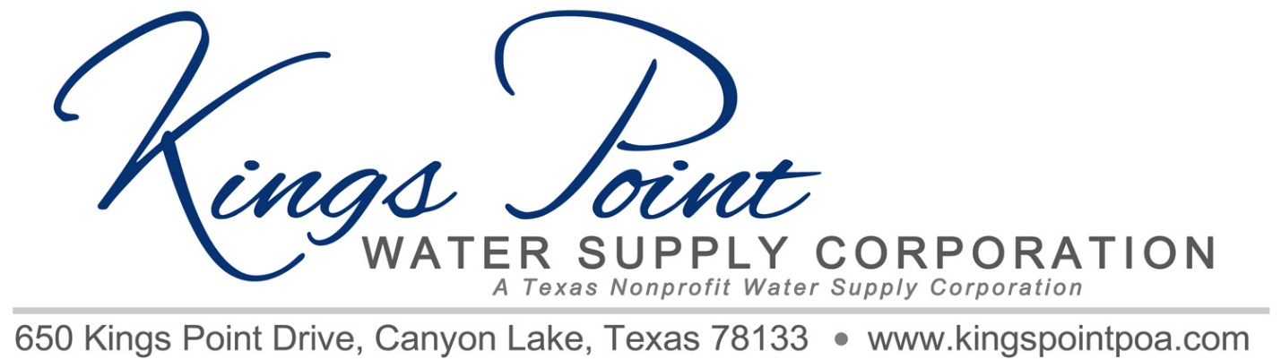
Agenda
Board of Directors Meeting
June 17, 2019 - Noon - Kings Point Pavilion

Call to Order
Determination of Quorum
Proof of Notice
Adoption of Standing Rules
Approval of Previous Minutes
Treasurer's Report
Old Business:
- Pavers
  - Removal and Placement
  - Labor and Materials
- Website Startup
- Locating Valves
- Meter Readings

New Business:
- 2019 Backflow Inspections
- Well Electrical Problems
- Hammering Problems - Options
- Placement of Chlorine Injection to Stop Line Leaking
- Pump House Problems

Schedule Next Meeting

Discussion
Adjournment

