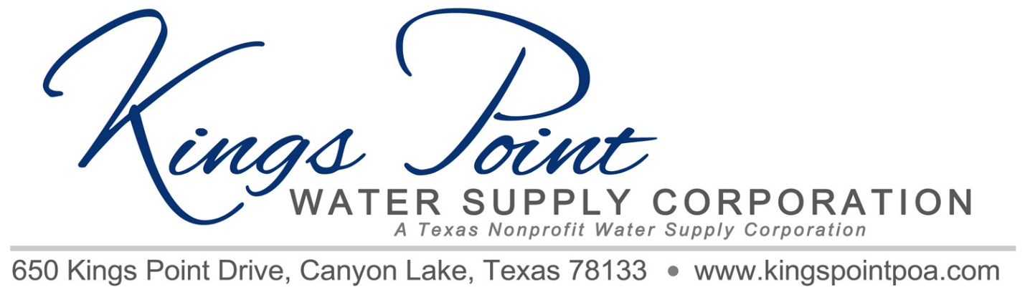
Agenda
Board of Directors Meeting
January 28, 2023 – 11 a.m. - Kings Point Pavilion

Call to Order
Determination of Quorum
Proof of Notice
Adoption of Standing Rules
Approval of Previous Minutes
Treasurer's Report
Old Business:
- Well House Upgrades
- Bleach Purchases
- Variance Report Update (Per Member’s Request at Last Meeting)
- Status of Back Flow Device Replacement Requirements
- Status of Inground Distribution Line Valves, including locating and testing

New Business:
- 2023 Budget
- Annual Meeting Planning
- President’s Report - 2022 Accomplishments
- Standpipe External Inspection for Leaks and Rust
- Water Level Readings for Main Well
- Standpipe Pump Run Procedure
- Well House Roof & Further Upgrade Needs
- Fence Repair & New Gate

Schedule next meeting

Discussion

Adjournment

