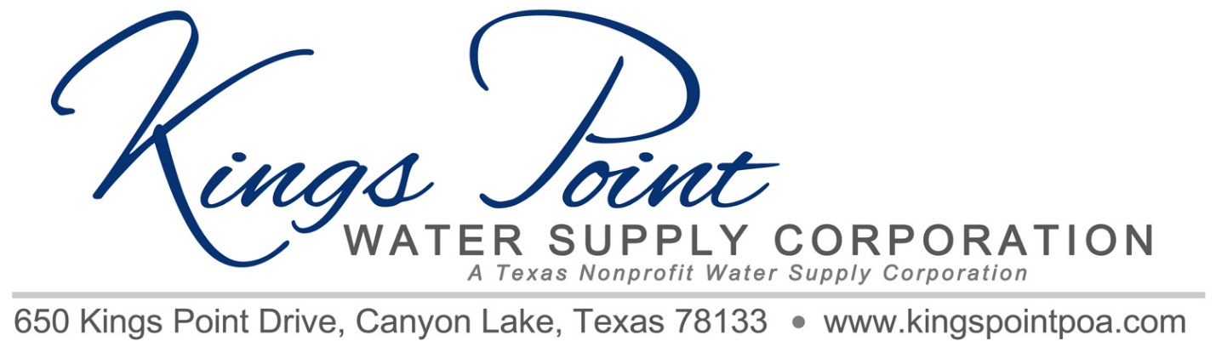
Agenda
Board of Directors Meeting
April 1, 2022- 2:00PM - Kings Point Pavilion

Call to Order
Determination of Quorum
Proof of Notice
Adoption of Standing Rules
Approval of Previous Minutes
Treasurer's Report
Old Business:
- Repairs
- Progress report on Generator, Propane Tank and Well Site Upgrades/Insurance
- TCEQ Power Outage Requirements Senate Bill 3/Emergency Plan Status
- Valves
- Standpipe Rental Agreement

New Business:
- 2022 Budget
- Resolution Declaring Unopposed Candidates Elected
- Annual meeting and discussion
- Resolution
- Transfer of Money to Savings/Reserve Fund

Schedule next meeting - Annual Meeting

Discussion
Adjournment

